Your 6-second Federal Contracting Capability Statement
Neil McDonnell / www.GovConChamber.com
Business Development Apr 26, 2023
8:03
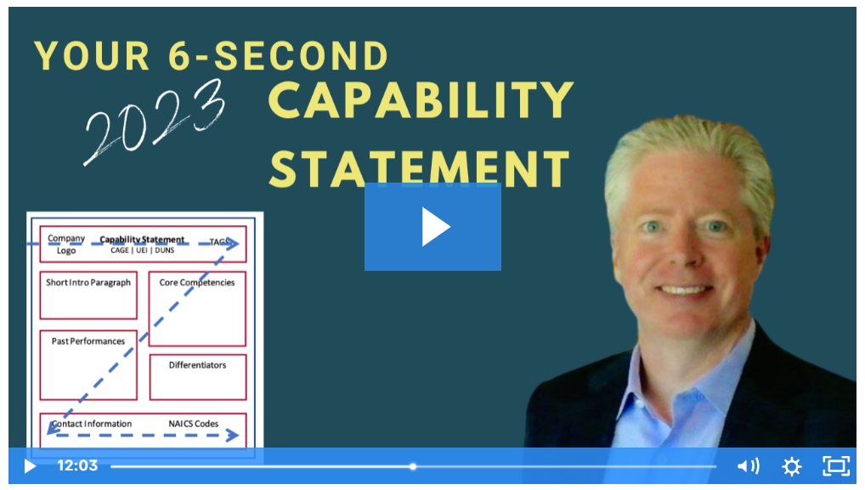0:00
How to Write 6-second Capability Statement for Government Contracting

The real purpose of a capability statement is to open doors.
Capability statements are the most important marketing tools for small business government contractors.
A well-written statement will open doors and persuade government small business specialists to connect you with program officers.
- This is just one of the 6 Essential Marketing Assets for Small Business Government Contractors in the Federal Marketplace
In the market research phase, government buyers are just trying to collect a pool of 'generally qualified' vendors and don't have time to read lengthy documents. They are just trying to get a group to forward to the actual buyers – the program officers.
You only have 6 seconds to hook their interest and using clear concise language, you must tell them –
- that you are 'procurement ready'
- what good or professional services you sell
- what government agencies or commercial entities have paid you in the past

Why do we recommend a 6 second capability statement?
Depending on the industry, location and size and scope of the procurement, government buyers receive hundreds or even thousands of statements from interested vendors every year.
Your statement must grab their attention so you can rise above your competition and really be seen by federal buyers and decision makers.
The truth is that government buyers only scan capability statements before deciding whether to toss or forward it in the process.
Those 6 seconds are crucial so you must craft a statement that quickly and effectively communicates your value proposition and key qualifications.
It's an elevator pitch, not the whole story and not your resume.
* Learn more with Neil's interview with Dept of Energy Small Business expert Loni Macrae 2018 interview

Why a Z format?
The eye naturally moves across a document in a Z pattern – starting in the top left corner, moving diagonally to the top right corner, then down to the bottom left corner, and finally diagonally to the bottom right corner.

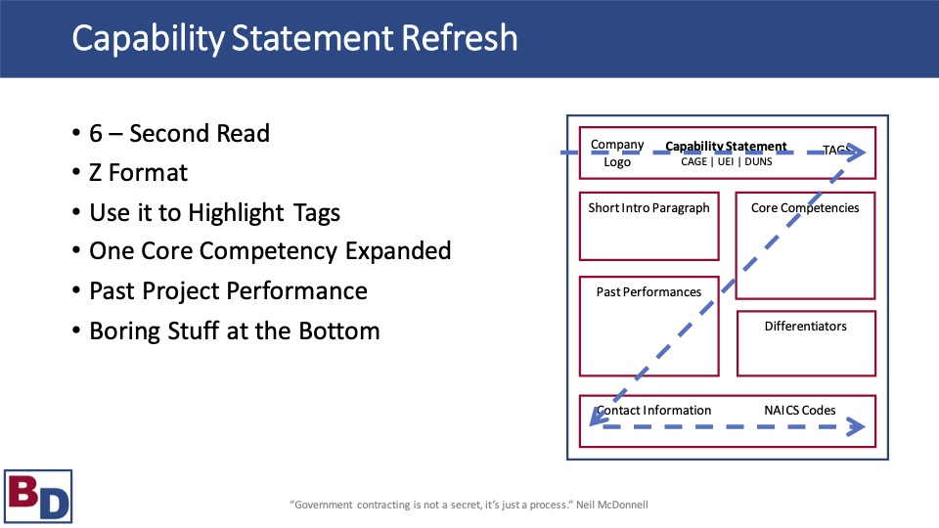

What should you include in a one-page capability statement?
HEADER: * the most important information!
- Company name and logo
- Title: "Capability Statement"
- Cage Code and UEI (shows 'procurement ready' and registered in SAM.gov)
- Logos for any socio-economic tags (HUBZone, veteran or women-owned small business, #wosb #sdvosb)
- All contract vehicles that you are on (hyperlink to GSA or STARS III profile if appropriate)
- Hyperlink CAGE and UEI to DSBS profile
CORE COMPETENCIES
- your clear 'focused offer'; one easy to read Core Competency​
PAST PERFORMANCE
- This section should highlight your company's past performance on relevant contracts or projects. Use specific examples and metrics to demonstrate your company's capabilities and achievements. Even as a subcontractor, you demonstrate your consistency in recognized government agencies. Only list 4-6 federal and state (list commercial only if necessary)
- Who you have worked for and sample projects.
DIFFERENTIATOR
- This is less important than your past performances
- Differentiators may include things like facility clearance levels, relevant certifications, licensings or bonding levels, depth of agency experience
- Relevant intellectual property (like patents)
- Staff uniqueness (academic credentials, employee retentions, volume of certified-specialists),
ABOUT
- Your hook that leads to your pitch
- 14 pt font;
FOOTER
- Boring stuff on the bottom ​(NAICS numbers);
- List your company's specific point of contact (not generic)
- 12 pt font
• FORMAT REMINDERS
- Use clean text font so document scans accurately
- Review periodically to keep information current
- If possible, your capability statement should be tailored to the specific agency or opportunity that you're targeting. Do your research and make sure that you understand the agency's mission and goals, as well as any specific requirements for the opportunity.
By including these critical components in your one-page capability statement, you can create a clear, concise, and effective document that quickly and effectively communicates your value proposition and key qualifications to government buyers.

WHERE can you distribute your Capability Statement?
- Company website (ungated)​
- LinkedIn Profile (In both Experience and Featured sections)​
- LinkedIn Company Page
- Large Prime Supplier Portals
- Agency Supplier Portals
- Agency Enterprise Search (hard drives)​

In conclusion, your concise 6-second capability statement for government contracting is a powerful document that will set you apart from the competition.

